Stoic Solutions

Report 0

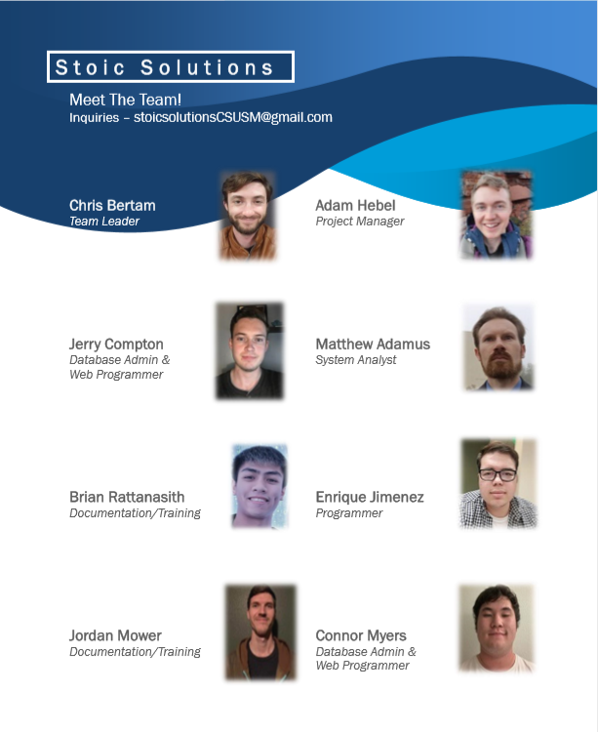

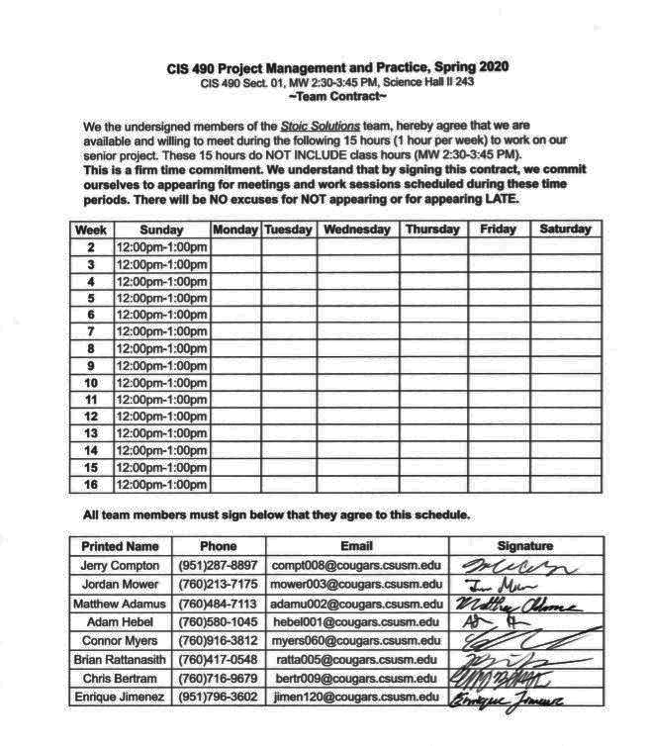

**CIS 490 Project Management and Practice, Spring 2020**

CIS 490 Sect. 01, MW 2:30-3:45 PM, Science Hall II 243

**~Team Contract~**

We the undersigned members of the *Stoic Solutions* team, hereby agree that we are

available and willing to meet during the following 15 hours (1 hour per week) to work on our senior project. These 15 hours do NOT INCLUDE class hours (MW 2:30-3:45 PM).

**This is a firm time commitment. We understand that by signing this contract, we commit ourselves to appearing for meetings and work sessions scheduled during these time periods. There will be NO excuses for NOT appearing or for appearing LATE.**

|  |  |  |  |  |  |  |  |
| --- | --- | --- | --- | --- | --- | --- | --- |
| **Week** | **Sunday** | **Monday** | **Tuesday** | **Wednesday** | **Thursday** | **Friday** | **Saturday** |
| **2** | 12:00pm-1:00pm |  |  |  |  |  |  |
| **3** | 12:00pm-1:00pm |  |  |  |  |  |  |
| **4** | 12:00pm-1:00pm |  |  |  |  |  |  |
| **5** | 12:00pm-1:00pm |  |  |  |  |  |  |
| **6** | 12:00pm-1:00pm |  |  |  |  |  |  |
| **7** | 12:00pm-1:00pm |  |  |  |  |  |  |
| **8** | 12:00pm-1:00pm |  |  |  |  |  |  |
| **9** | 12:00pm-1:00pm |  |  |  |  |  |  |
| **10** | 12:00pm-1:00pm |  |  |  |  |  |  |
| **11** | 12:00pm-1:00pm |  |  |  |  |  |  |
| **12** | 12:00pm-1:00pm |  |  |  |  |  |  |
| **13** | 12:00pm-1:00pm |  |  |  |  |  |  |
| **14** | 12:00pm-1:00pm |  |  |  |  |  |  |
| **15** | 12:00pm-1:00pm |  |  |  |  |  |  |
| **16** | 12:00pm-1:00pm |  |  |  |  |  |  |

**All team members must sign below that they agree to this schedule.**

|  |  |  |  |  |
| --- | --- | --- | --- | --- |
| **Printed Name** | **Phone** | **Email** | **IP** | **Signature** |
| Jerry Compton | (951)287-8897 | compt008@cougars.csusm.edu | 47.148.244.78 |  |
| Jordan Mower | (760)213-7175 | mower003@cougars.csusm.edu | 76.176.184.56 |  |
| Matthew Adamus | (760)484-7113 | adamu002@cougars.csusm.edu | 76.176.185.34 |  |
| Adam Hebel | (760)580-1045 | hebel001@cougars.csusm.edu | 68.7.181.220 |  |
| Connor Myers | (760)916-3812 | myers060@cougars.csusm.edu | 68.6.201.225 |  |
| Brian Rattanasith | (760)417-0548 | ratta005@cougars.csusm.edu | 98.176.90.120 |  |
| Chris Bertram | (760)716-9679 | bertr009@cougars.csusm.edu |  |  |
| Enrique Jimenez | (951)796-3602 | jimen120@cougars.csusm.edu | 142.129.199.134 |  |
| CSUSM NETWORK |  |  | CIDR RANGE |  |